Nexora automation controllers
Document 21 of the Nexora learning guides
Source snapshot 14 October 2026 at 06:41 UTC
Understand the Attributes, Rules and Design controllers for configuring entity forms.

Recognise the screen and its scope
Open /automations, /automations/type/[automation], /automations/[module]/attributes-controller, /automations/[module]/rules-controller, /automations/[module]/design-controller. CRM routes use port 3017; member routes use 3018; public website routes can use 3019. Brackets name a route parameter, not text to paste into a browser. Choose a real record or site id from the application.
This guide covers Choose controller then entity; Typed custom attributes; Formula and conditional rules; Section layouts and visibility; Metadata and validation; Applying configured sections on record forms.
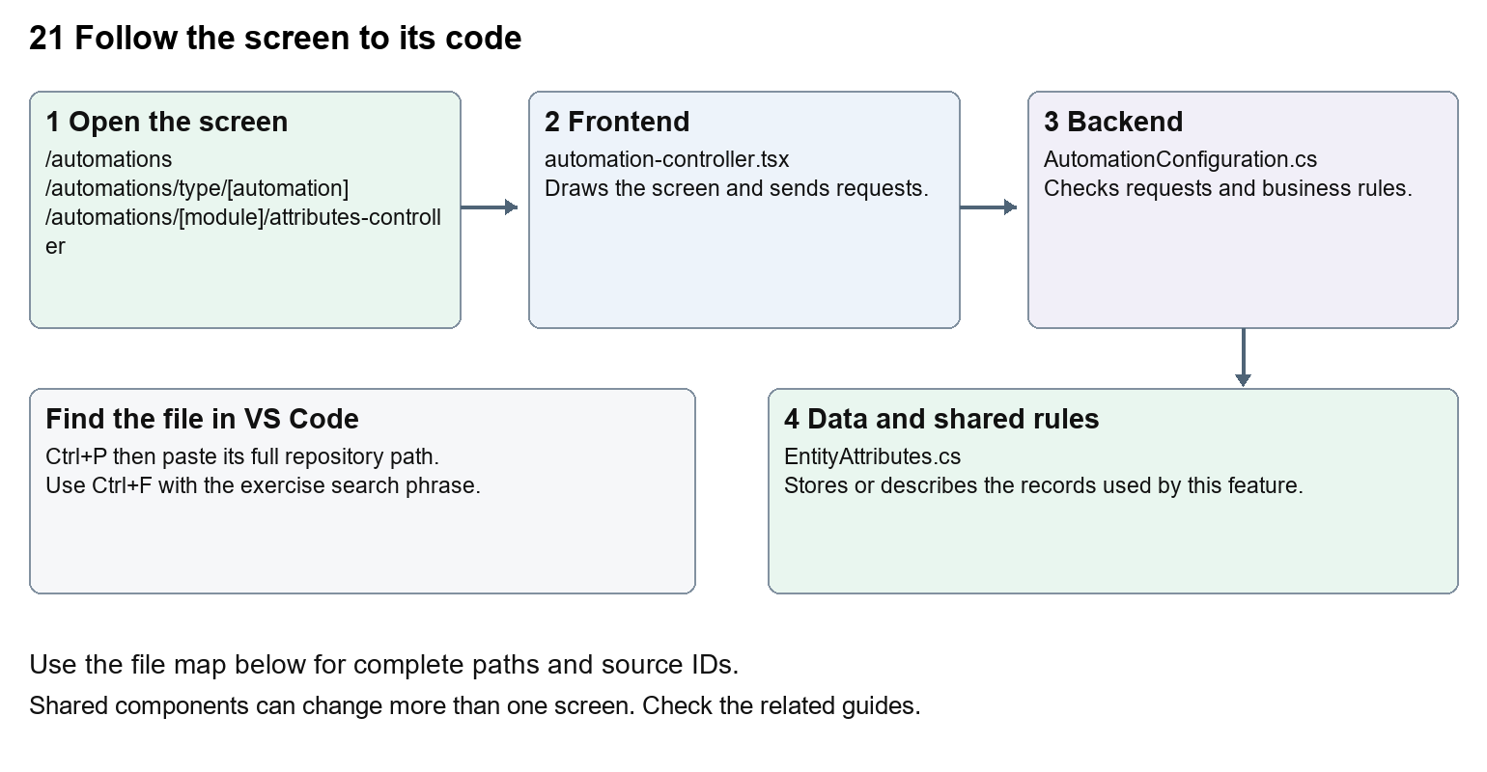
The diagram shows the file roles. The full paths below are what you paste into Ctrl+P.

Find the files in VS Code
Role | File and source ID | What it does
Screen | S0136 automation-controller.tsx | Main UI or route for this topic
Server | S0192 AutomationConfiguration.cs | Endpoints or server rules
Data | S0194 EntityAttributes.cs | Data shape or persistence structure

Screen S0136
apps/web/src/features/shared/automation-controller.tsx
Server S0192
backend/src/BuildingBlocks/Nexora.BuildingBlocks/Persistence/AutomationConfiguration.cs
Data S0194
backend/src/BuildingBlocks/Nexora.BuildingBlocks/Persistence/EntityAttributes.cs
The complete HTML manual opens these source IDs inside its Source library. The Word manual shows short labelled extracts so you can learn the flow before reading large files. Each individual Markdown guide includes its complete primary files after the walkthrough.

Follow the request and the records
1. The automation menu chooses controller type and module.
2. Metadata provides entities and supported fields.
3. The controller edits attribute, rule or section definitions.
4. Shared backend endpoints validate and store configuration.
5. Record forms render configured fields, and server save rules apply configured calculations.

Read the code with an explanation
A controller changes configuration for records, while a workflow coordinates a sequence of actions. Attributes define extra data, Rules calculate or condition values, and Design arranges record sections. Several modules reuse the same controller UI and BuildingBlocks storage. Changes to shared metadata can affect every registered module.
Source reference S0136 apps/web/src/features/shared/automation-controller.tsx
Selected opening lines with their original numbers. The complete file is in the HTML source library.
0001 "use client";
0002 import { EntityHeading } from "@/components/ui/entity-heading";
0003 import { useEffect, useRef, useState } from "react";
0004 import Link from "next/link";
0005 import { attributeEntities, entityLabel, reconcileSections } from "./attribute-entities";
0006 import { useAttributeEntities } from "./use-attribute-entities";

The import lines lead to shared components and helpers. Start at the exported component or route function; follow the request helper to the server rather than assuming the whole feature lives in this file.
Source reference S0192 backend/src/BuildingBlocks/Nexora.BuildingBlocks/Persistence/AutomationConfiguration.cs
Extract from source line 60. A fragment from a long line is shown without the rest of that line.
0060 api.MapGet("/automations/{entityType}", async (string entityType, TDb db, IRequestIdentity who, HttpContext http, CancellationToken ct) =>

On the server, look for MapGet to load records, MapPost to create or perform an action, MapPut or MapPatch to change data, and RequireAuthorization for permissions. Some shared methods register endpoints indirectly. Find SaveChangesAsync to see the database write. A request method alone does not tell you every side effect.
Source reference S0194 backend/src/BuildingBlocks/Nexora.BuildingBlocks/Persistence/EntityAttributes.cs
Selected opening lines with their original numbers. The complete file is in the HTML source library.
0001 using System.ComponentModel.DataAnnotations;
0002 using Microsoft.AspNetCore.Builder;
0003 using Microsoft.AspNetCore.Http;
0004 using Microsoft.AspNetCore.Routing;
0005 using Microsoft.EntityFrameworkCore;
0006 using Microsoft.Extensions.DependencyInjection;

Follow model fields to their request names and database mapping. An id points to a particular record. A tenant id limits the organisation. A version or concurrency stamp protects newer edits. Some model files describe contracts rather than tables; check the owning DbContext before assuming storage.

Make or trace your first change
1. Press Ctrl+P and open apps/web/src/app/(platform)/automations/page.tsx.
2. Press Ctrl+F and search for Choose an automation type first, then select the entities it should apply to.. In this snapshot it appears at line 10.
3. Replace only the introduction sentence. Open the controller menu and follow one entity into each controller without saving configuration.
4. Replace only Choose an automation type first, then select the entities it should apply to. with Choose a controller, then choose the records it should apply to. in that intended location. Keep quotes, tags, JSON keys and routes intact.
5. Save with Ctrl+S. Inspect Problems and the local screen. Review the diff and restore the original text when you finish practising.
Extract from source line 10. A fragment from a long line is shown without the rest of that line.
0010 Name="mt-2 text-sm text-slate-600">Choose an automation type first, then select the entities it should apply to.</p></header><section className="grid gap-4 s

These exercises have not been applied to the application. Their search phrases are verified against the captured source. Line numbers can move; the phrase and file path are your main navigation aids.

Check a change and diagnose problems
Confirm the original screen still loads, the changed words appear in the intended place, and another screen using the same component still behaves correctly. If an action fails, inspect the browser Network response, the relevant helper and server validation message. Use the common error table at the beginning of the manual. Reload on a version conflict instead of removing the version check.
A syntax error after a text edit usually means a quote, brace or closing tag changed. Compare your diff with the original. An unchanged browser result can mean the wrong port, a saved published configuration overriding a default, or a running API that has not reloaded.

Understand the current limits
Configuration edits can affect many forms and future saves. Formula syntax and entity metadata must remain valid. Styling defaults are separate from per-entity configuration.

Continue learning
Related guides 08 Nexora record profiles and related information, 11 Nexora membership setup and products, 22 Nexora workflow designer and runtime.

